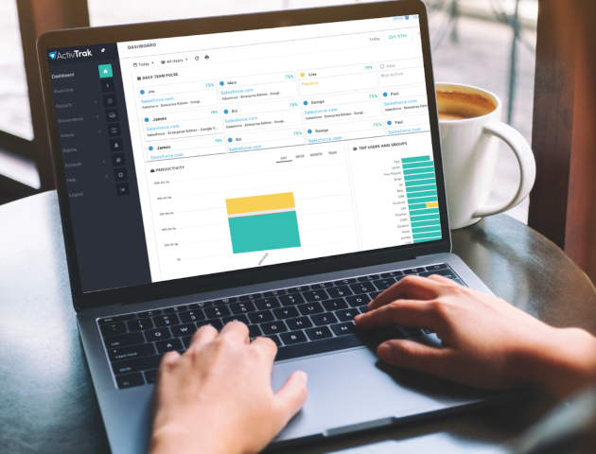

Introducing ActivTrak To Your Organization

Organizations work best when everyone has clarity on their company’s mission and objectives. That’s why we recommend being transparent with employees about your use of ActivTrak. There are four (4) key areas to keep in mind when planning to implement ActivTrak in your organization.

- Communicate often. Communication is critical prior to your implementation, throughout your implementation, and on an ongoing basis to share insights.
- Be transparent about your intent and how the data will be used throughout the process.
- Encourage ownership in the results. Include your workforce in not only the findings, but also the solutions.
- Culture is key. Through focusing on areas 1-3, you’ve made it clear that transparency, improvement, and collaboration are paramount. Reinforce this message wherever possible.

ActivTrak Email Announcement Template
On the next page, you will find a sample of an email announcement that can be customized as a first step towards introducing ActivTrak to your organization.

Good Morning Team,
At [Company Name], we care about achieving our business goals, and we also care about how we are achieving these goals in terms of making the best use of our people, processes and technology.
We recognize that there are always ways that we can improve, and better support our teams. Whether it’s evaluating working arrangements, workloads, process efficiency, or technology tools, there are always ways we can better enable productivity.
For this reason, we’ve decided to leverage a workforce analytics and productivity management platform called ActivTrak.
ActivTrak collects and categorizes user activity data to help us all answer questions such as:

Time Allocation:
- How much time are we spending in meetings?
- Are we scheduling these at a time that’s least disruptive to the team?
- Are teams able to spend enough time on focused work each day?
- How can we better leverage that time with the right activities?
- Are employees at risk of burnout, or are workloads unevenly distributed?

Training and Resources:
- Are we spending a lot of time searching for answers to questions to do our jobs?
- Do new employees need more training?
- What apps and websites are teams using to get their work done?
- Are there unused apps that we no longer need?

Performance:
- Are there ways we can learn from others to do our own work better or faster?
- Are there ways we can measure performance more objectively?

There are many areas of our business that we can improve upon, and this is a tool that can enable us to leverage data rather than speculation to guide our business decisions.

But we don’t just want managers using this data. We encourage all people managers to share data and trends with individual employees and teams so that everyone can discuss productivity obstacles and collaborate on solutions.

We understand the intentions of a tool like this one can easily be misconstrued without additional context which is why we are being transparent about this decision and openly engaging in the conversation with all of you. It is also why we chose a vendor who promotes performance insight, not oversight.

In an effort to expand on our ActivTrak rollout plan and to address any of your questions and concerns, we will be hosting a company-wide conversation on {insert date} that will also be recorded. Please keep an eye out for the calendar invitation this week.

We appreciate all of your hard work and adaptability, and we look forward to hearing your input as we continue to enhance our workplace into one that is both focused and flexible.

Thank you,
{Name}
{Title}

